Ausramp changes 14/11/2024

**HOME PAGE:**

1: Remove twitter and Linkdin- Ausramp only have faceboook and Instagram



Make sure this is the same across the whole site

2: two different sizes   
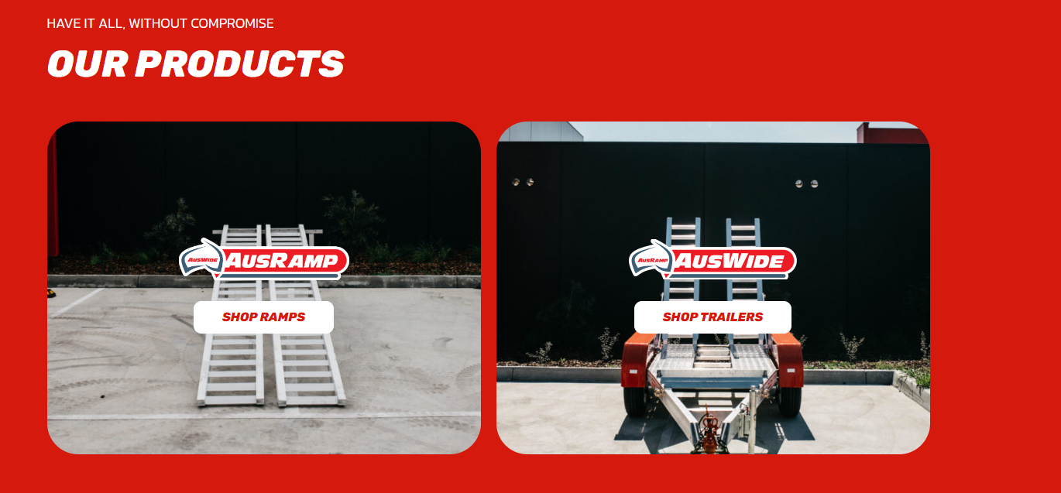

The left and right images appear mismatched, with one being zoomed in and the other zoomed out.

3: Remove text-

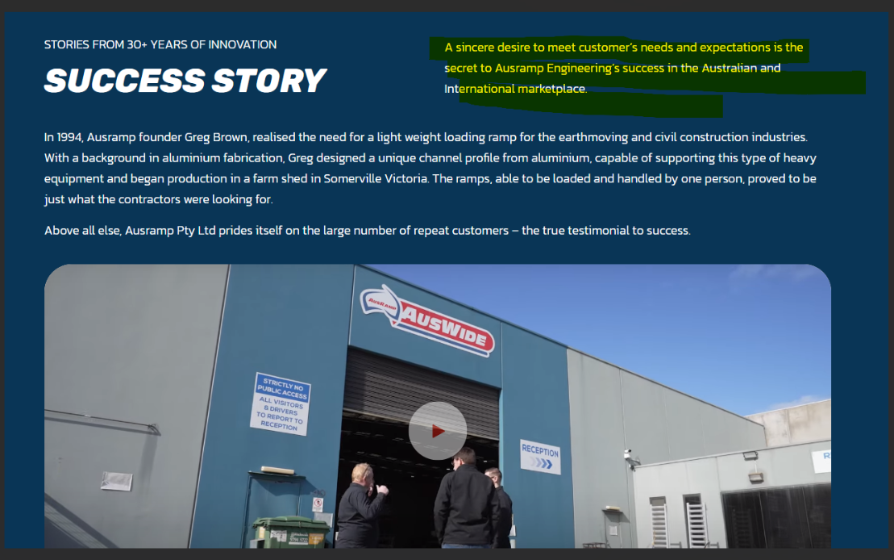

4: Text looks off – Please left align text 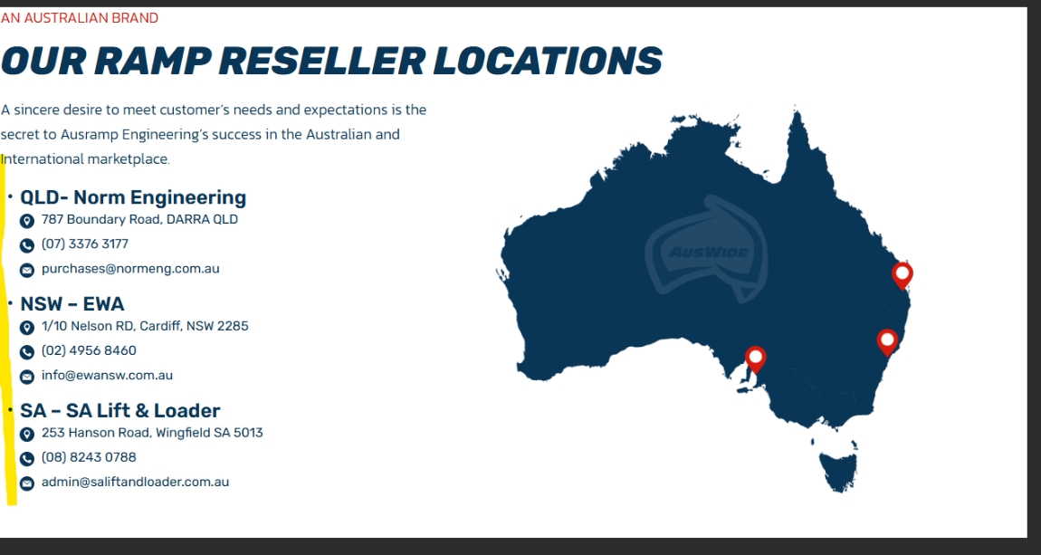

5: Logo looks weird as its cut off from the side… please send this to the right of the section so its not cut off

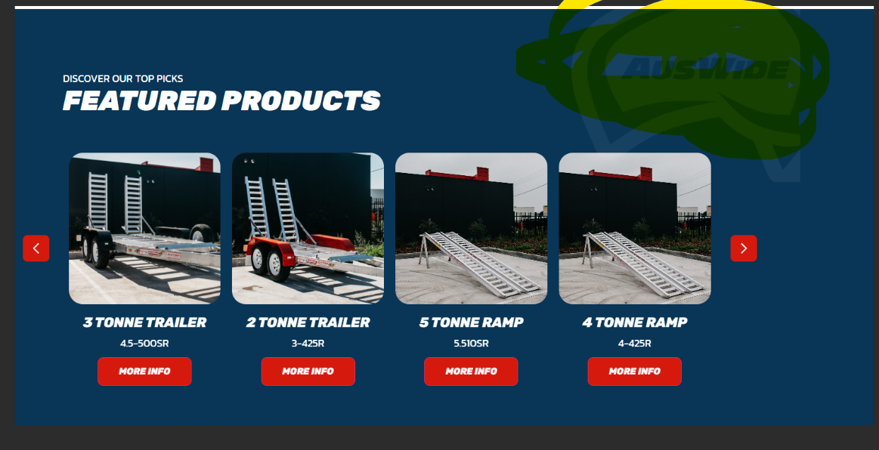

6 : Add dummy text to FAQ section for now.

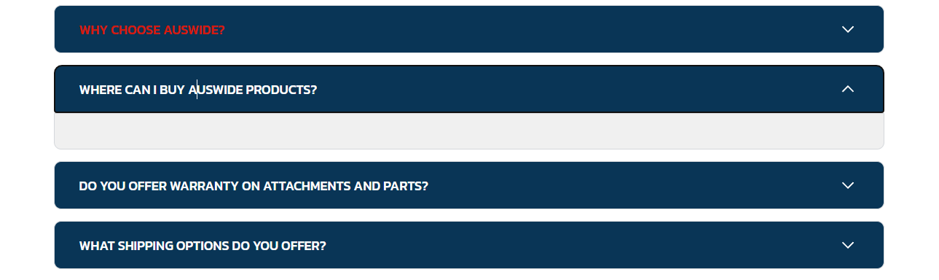

7: Throughout the site, could you update this to a "Contact Us" section? Ausramp no longer has a brochure available. Make sure it leads to contact us page’s contact form.   


8: When you click on Ramps and trailers on the fotter section the headings are not red like the other sections.

  
Example : About us 

Trailers: Not red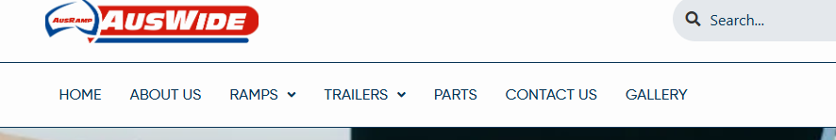

9: WHOLE site is missing the terms and conditions page/ Privacy policy & Faq page.. this all can be found in the Figma file. 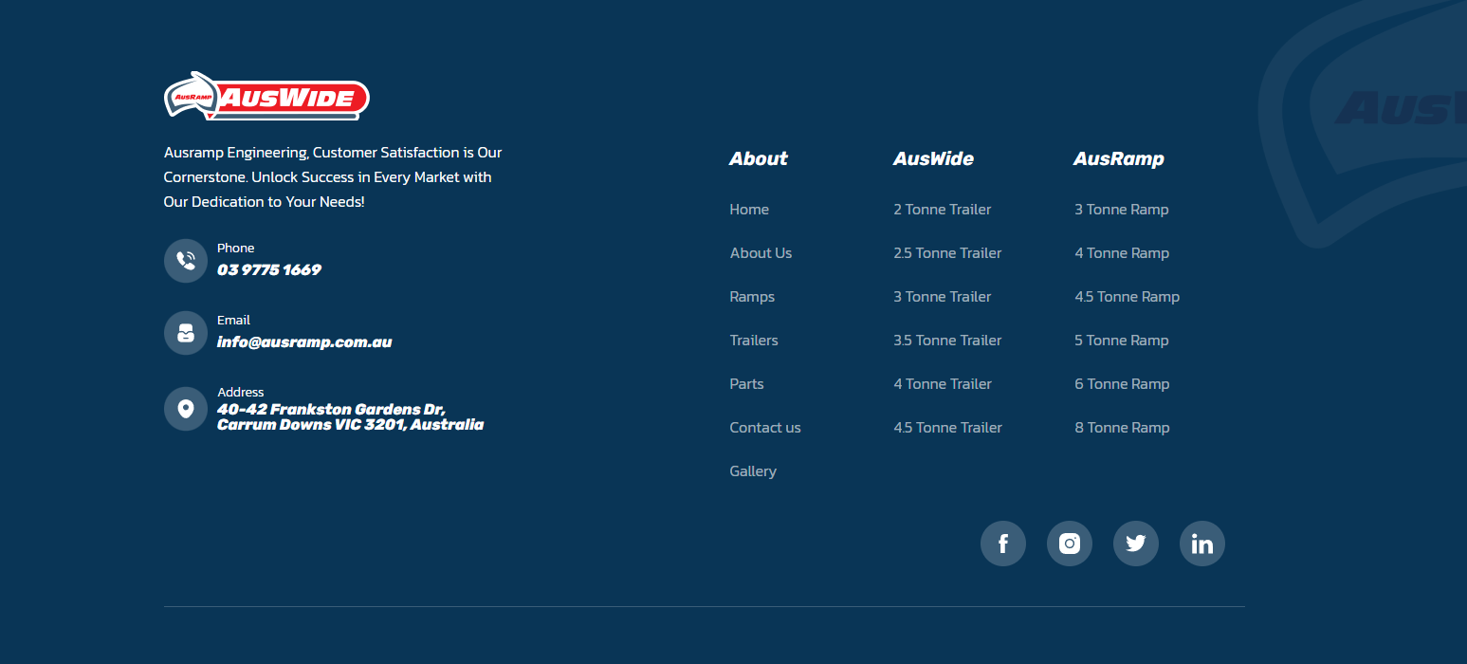

-Add the T&C’s + Privacy policy to the bottom of the page – follow example   
-You also need to add “ Copyright © AusWide Equipment Pty Ltd 2024. All rights reserved | Website built by Tactik ( Link to tactik site)   
-For the FAQ page add it under heading “ Gallery”

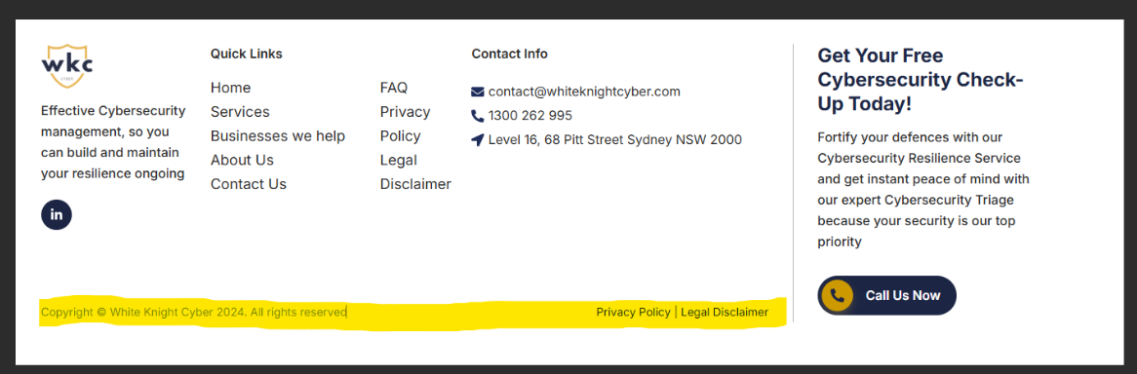

10: Could you update the headings as follows: change "About" to "Quick Links," "Auswide" to "Trailers," and "Ausramp" to "Ramps"? ALSO link the trailers and ramp page to the main trailer and ramp pages.

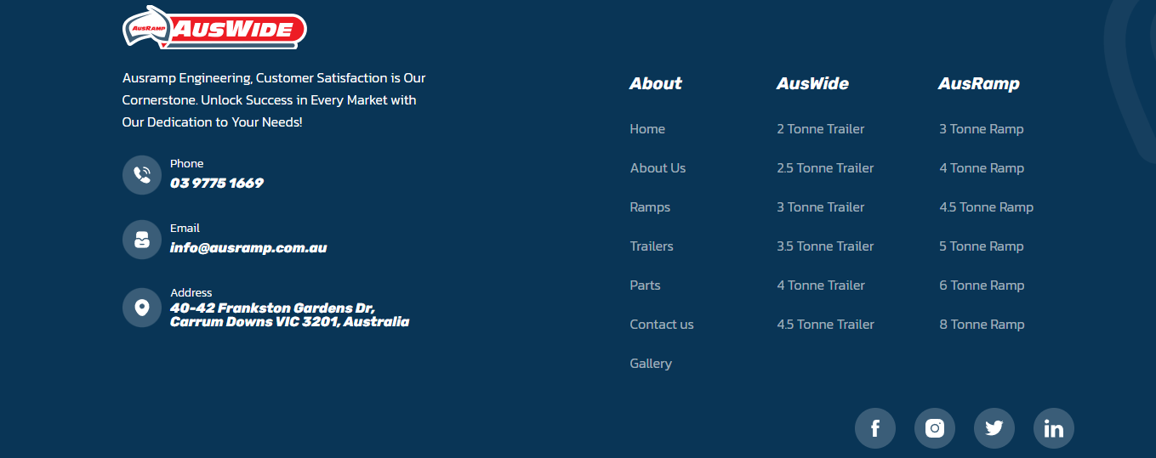

ABOUT US PAGE:

1: Same issue as number 3 &4 on home page.

Main Ramp & Trailer page :

1: remove all stock codes form ALL pages on the website - 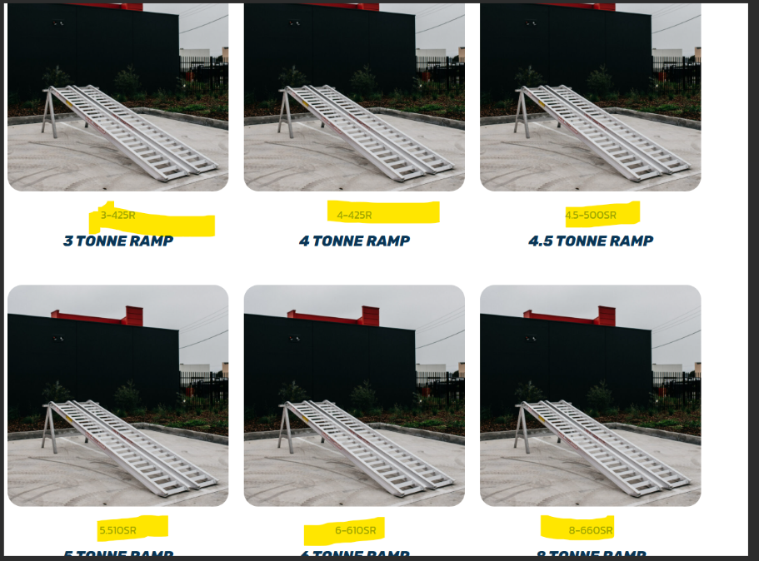

2: Same issue with the LOGO watermark – cut off please align it to the right. 

3: Could you switch the order of the two sections on the main Ramp and Trailer pages so that "The Range" appears first, followed by "Contact form"?

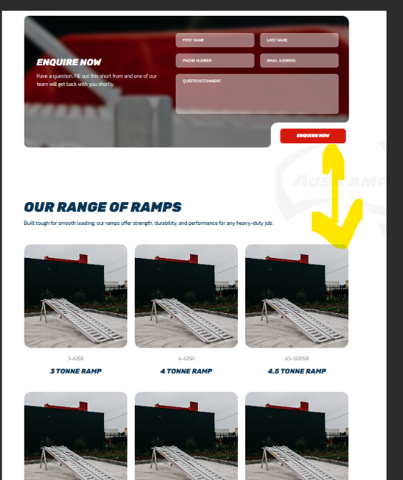

4: For both the RAMP and Trailer pages, could you use different images on the main page to avoid a repetitive look?

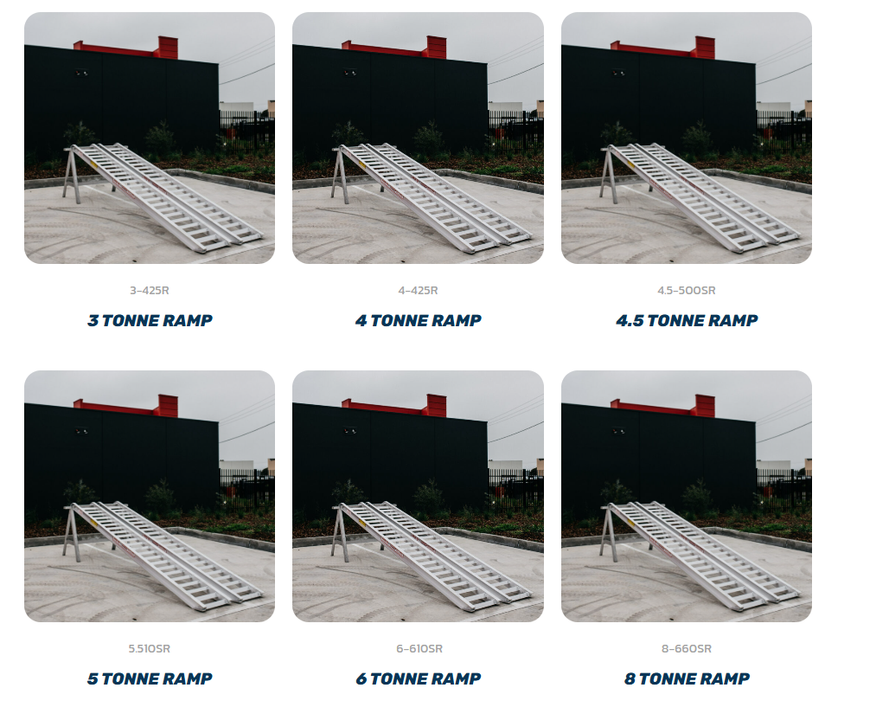

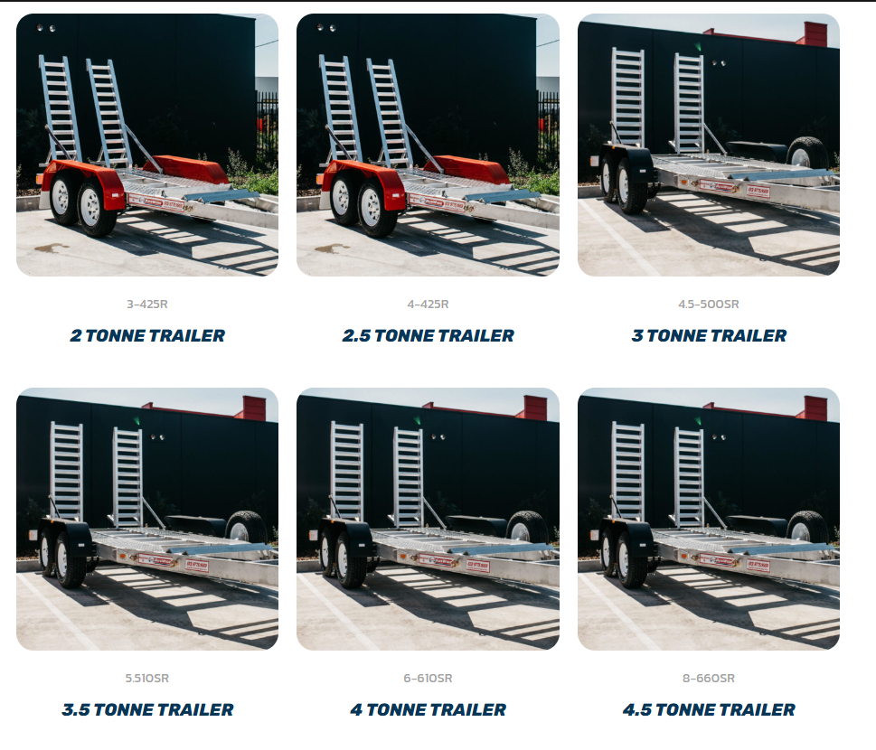

EXAMPLE :   
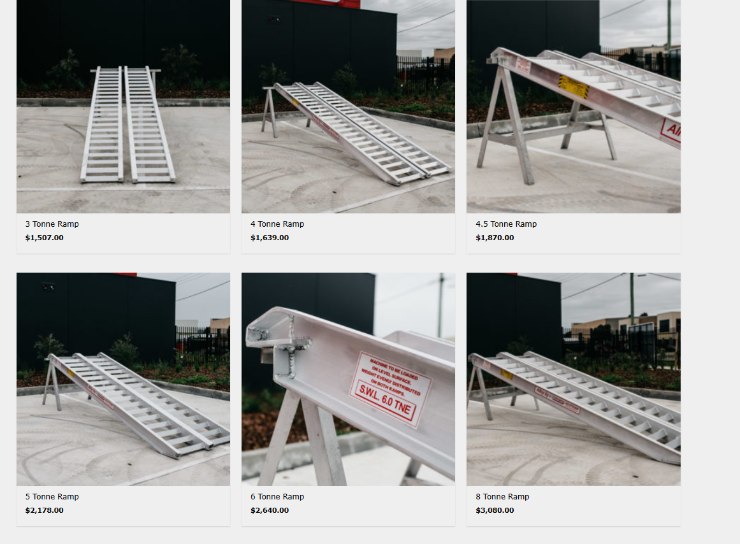

Parts and Contact pages are good

Gallery :

1: Remove this “Stories in motion” and keep this image in yellow and add it to the section above – ( The other images are all stock)

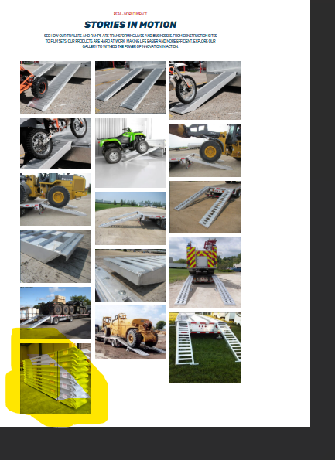

2: Also please add contact from to the bottom of the gallery page.

HEADER SECTION :

1: On the Ramps and Trailers pages, could we add links labelled "All Ramps" and "All Trailers" that direct users to the main Ramps and Trailers pages. This should come up first when someone clicks on trailers or ramps.

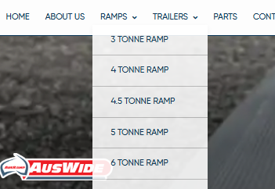

2 : Could we set up the search bar so that when someone clicks on it, images, product suggestions, or recommendations appear? Currently, it doesn’t display anything.



3: Change info text to the one on figma file – Current one is hard to read. 



PRODUCT PAGES:   
1: With the buttons on “ product description , machine applicable etc- Can we not have the button RED- as it takes the eyes away from the CTA button ( Enquire now)

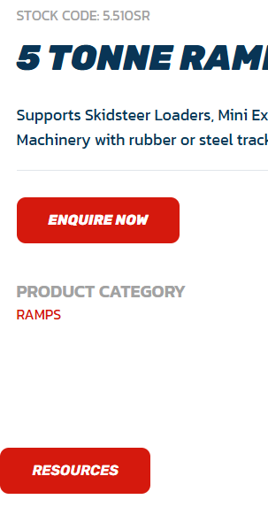

Have the button colour like this instead - 

2: For all product pages in the Trailer and Ramp sections, could you change the word "Resources" to "Download Product Brochure"? EACH product will have PDF that will be linked to it – Which is getting designed at the moment.

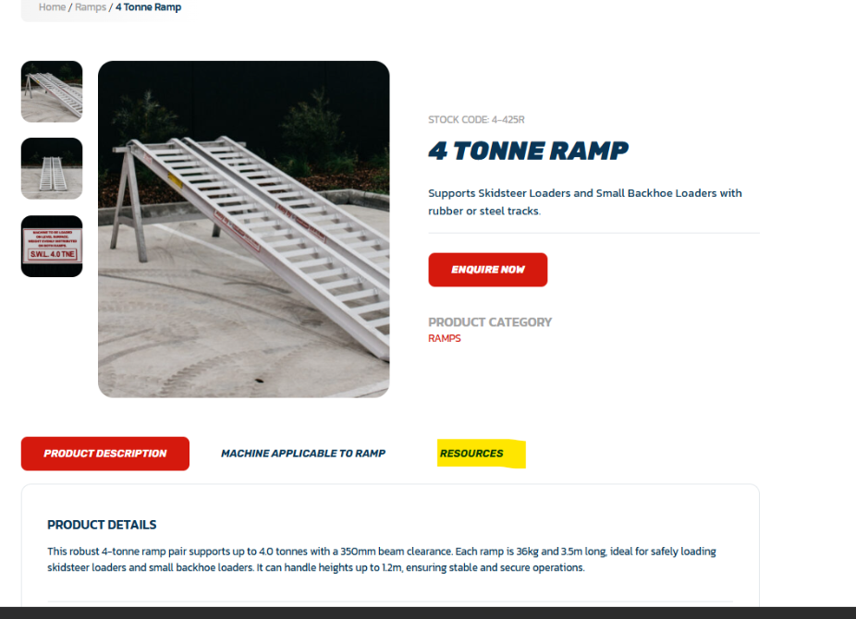

3: Also this is the old website - https://ausramp.archive.tactik.com.au/  
Can you please run through this old website and make sure all the information from each product page is applied to the new website.   
Example from old site: 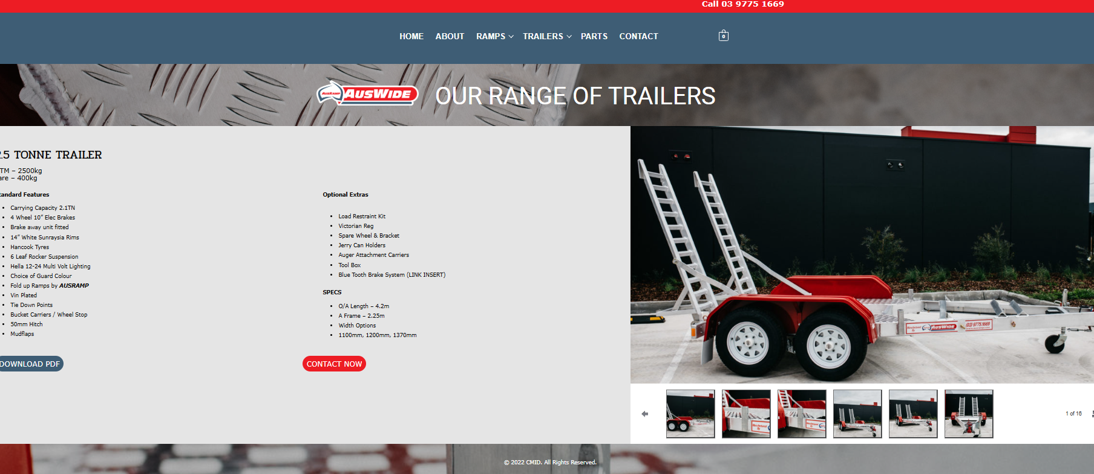

4: same issue with auswide logo.